Social Emotional Learning News

Choose Love/Gratitude
Students learn that gratitude is mindful thankfulness and the ability to be thankful even when things in life are challenging. When you practice gratitude you feel thankful and want to share that feeling with others (Donaldson, Dollwet & Rao, 2014). Children and adults who practice gratitude show more positive attitudes toward themselves and others. Topics students will be exploring include practicing “Gratitude Breaths”, identifying objects, people and things they are thankful for in their lives, practice listening skills and ways to show gratitude towards others.

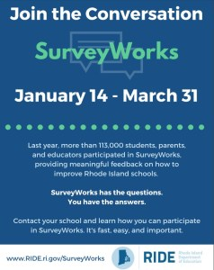SurveyWorks window goes through to March 31st. The surveys are focused on important topics that families are equipped to provide feedback on, including: School Safety, School Climate, Family Support, & Family engagement. It will take 20-30 minutes to complete the survey on a computer, tablet, or mobile device. To complete the survey, you may go to http://surveys.panoramaed.com/ride and enter WES school code 32103family to.
Grades 3 & 4 will be participating in SurveyWorks from March 4th ⁻ March 15th.

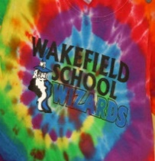PTO News

Community book club - Tale of Despereaux
Grateful doesn’t begin to capture how the members of our Wakefield School family feel toward Bronwyn Maguire and her extraordinary helpers, for providing us with the opportunity to participate in the community book club AND for transforming our school into a mystical castle and dungeon. We feel like we have been living alongside Despereaux, Chiaroscuro, The Princess and Mig! We have all enjoyed the weekly surprises to our “castle” and the take home crafts that have been sent home. Bronwyn and her elves have made this book club something beyond our wildest dreams and for this we are very grateful!

On January 24, Chris Poulus, BMX Champion came to share his bike stunts and inspirational message of respect, treating people well and practice, practice and practice some more! Thank you Chris Palmieri for another great cultural arts event!

was a great success! Thanks again to Karina Log for organizing this fun event for the whole family.

Back by popular demand….back by popular demand….back by popular demand…back by popular demand
THE PASTA SUPPER IS BACK!!!! Mark your calendars for April 26th! More information to come your way!

Our Next PTO meeting Feb 28, 5:00.

We are recycling and composting our food and waste at breakfast and lunch. Margaret Hayden spearheaded this effort and with the help of George our custodian and parent volunteers supporting the sorting of items, the process is going smoothly. If you are available to help during lunchtime, please click on the sign up link here.
https://www.signupgenius.com/go/4090D4BA4AB2EA0FE3-lunch

Title 1 Parent Information Meeting
Save the date: February 27, 2019 5:30-6:30
If your child has a Personal Literacy Plan, you will be invited to attend an informational night to address some of the topics related to literacy development and to answer questions you may have regarding the reading process.

Que pasa en español……
The Spanish classes are mastering our early conversational skills by exchanging information about our names and how we are feeling. We can also discuss the weather! We are continuing to talk about family vocabulary and are reading some short Spanish books that will be brought home! The culture classes finished up our conversations about the Three Kings and are now talking about how it is not a tooth fairy who visits Spanish speaking countries for lost teeth, but a mouse! We will also be discussing Valentine's Day traditions in some of the Spanish speaking countries.

What’s Happening in Health Class
As the New Year begins, students have started to learn about the different body systems. In kindergarten and first grade, students are learning about the 5 senses and how they can use these every day to become aware of their surroundings and help them stay safe and healthy. In second grade, students are learning about the digestive system and the process of how food is digested and turned into energy the body can use. Students will learn about
why eating healthy food and proper nutrition is important for their bodies. In third grade, students are learning about the skeletal and muscular systems. They are learning how they can keep their bones and muscles healthy and how these systems work together to help them with their daily activities. In fourth grade, students are learning about the circulatory, respiratory, and nervous
systems. They will be discussing ways to keep their heart, lungs, and brain healthy, personal habits they can start to keep these organs healthy and
habits they should avoid.

Nurse’s notes
By Amy Meade, RNCSNT
Handwashing I have been visiting the classrooms teaching lessons about germs, how they spread, what we can do to protect others and ourselves. Handwashing is one of the simplest and most effective means of preventing the spread of flu and other infectious diseases. Students learned and practiced proper handwashing technique. Wakefield Wizards ROC by covering their coughs and sneezes with their elbows and washing their hands often.
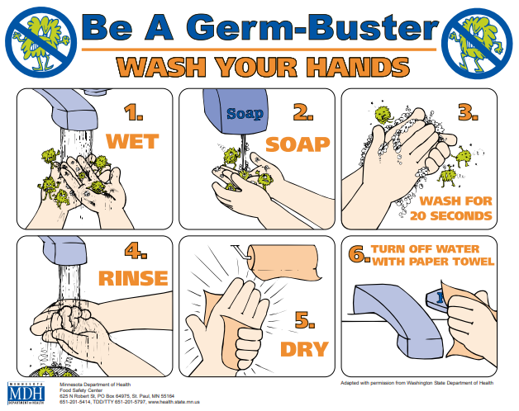

Flu is Widespread in RI If your child is experiencing flu symptoms, contact your health care provider for more information. Flu guide for parents from the CDC: https://www.cdc.gov/flu/pdf/freeresources/family/flu-guide-for-parents-2018.pdf
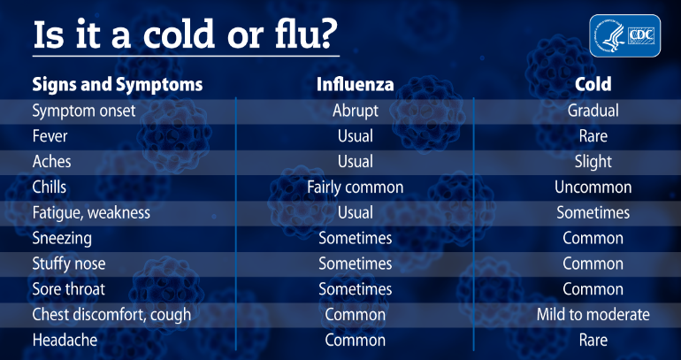
Vision Testing The state-mandated vision screenings are in progress. If your child does not pass, it is required that he or she be retested later. If the student does not pass upon rescreening, a vision referral will be sent home, accompanied by a phone call. If there is a referral, it is the parent's responsibility to follow up with a professional vision exam. If financial assistance is required to complete the exam, please contact me at 401-360-1406.
Winter Clothing Winter coats, hats, gloves and books are available at the school. If your child needs winter items, please contact the nurse's office at 401-360-1406
Contact information Please contact the school nurse's office if your child has an illness such as influenza, strep throat, norovirus or pink eye. Notices will be sent home to any affected classrooms.

